# **I. Thiết kế bộ FIR**

## **1. Số bậc của bộ lọc**

-Sử dụng cửa sổ Hamming.

### **1.1. Band 0-1khz**

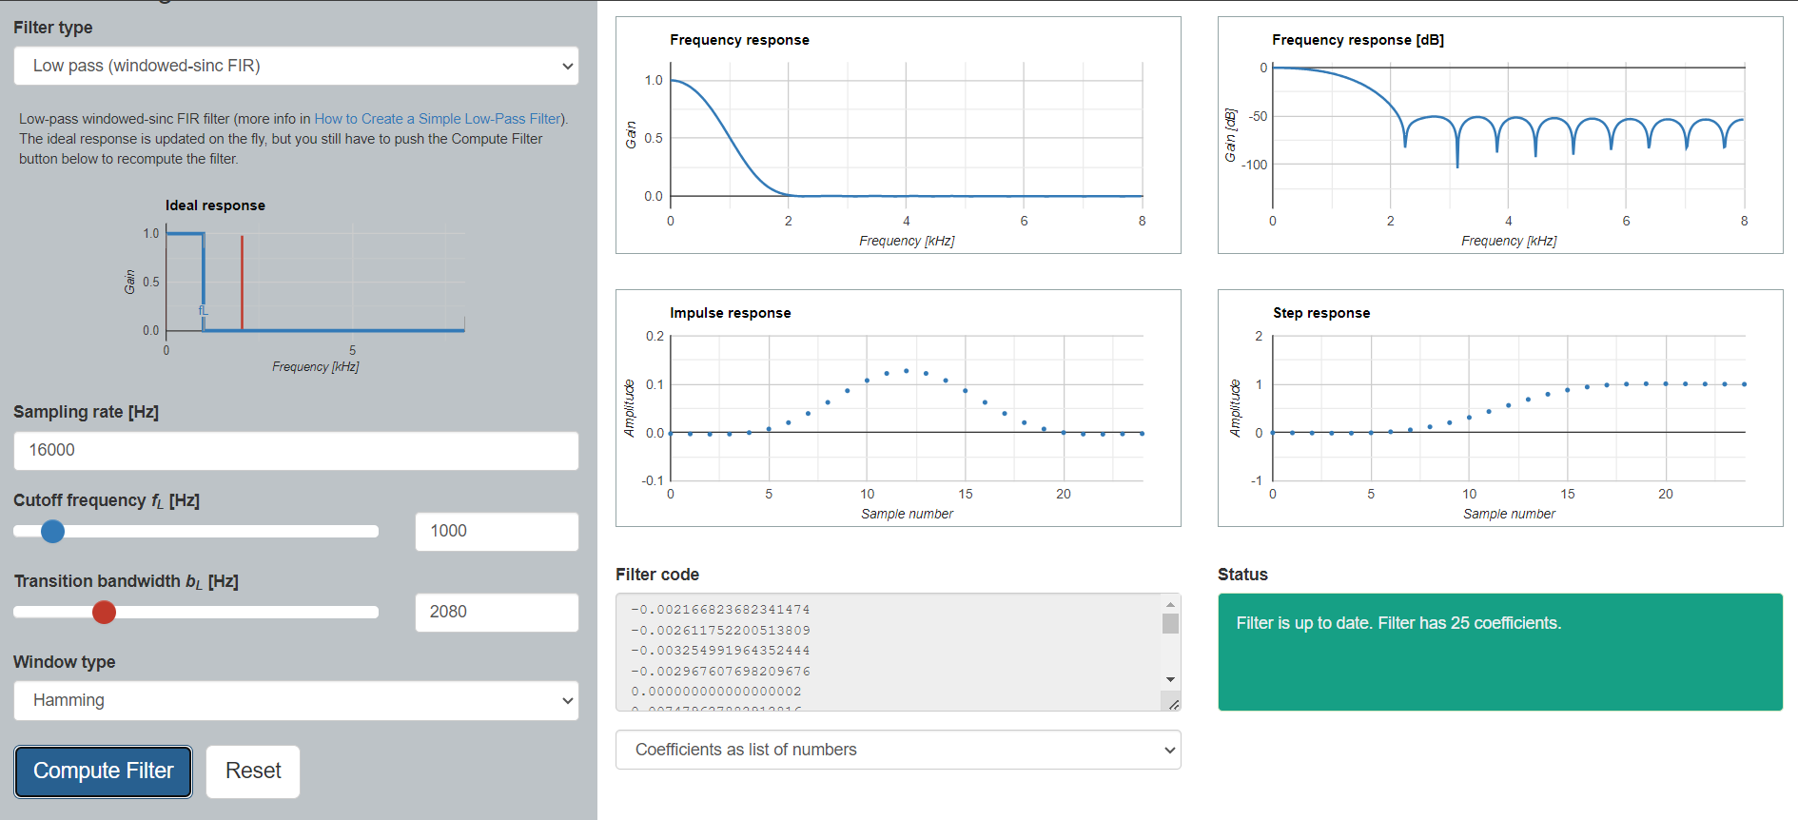

25 coefficients:

-0.002166823682341474

-0.002611752200513809

-0.003254991964352444

-0.002967607698209676

0.000000000000000002

0.007479627882912816

0.020684372212160029

0.039580656534898312

0.062567033827610030

0.086608422478043540

0.107831273451197932

0.122431563889203912

0.127636450538781643

0.122431563889203912

0.107831273451197945

0.086608422478043567

0.062567033827610058

0.039580656534898312

0.020684372212160032

0.007479627882912820

0.000000000000000002

-0.002967607698209677

-0.003254991964352447

-0.002611752200513812

-0.002166823682341474

### **1.2 Band 1-2khz**

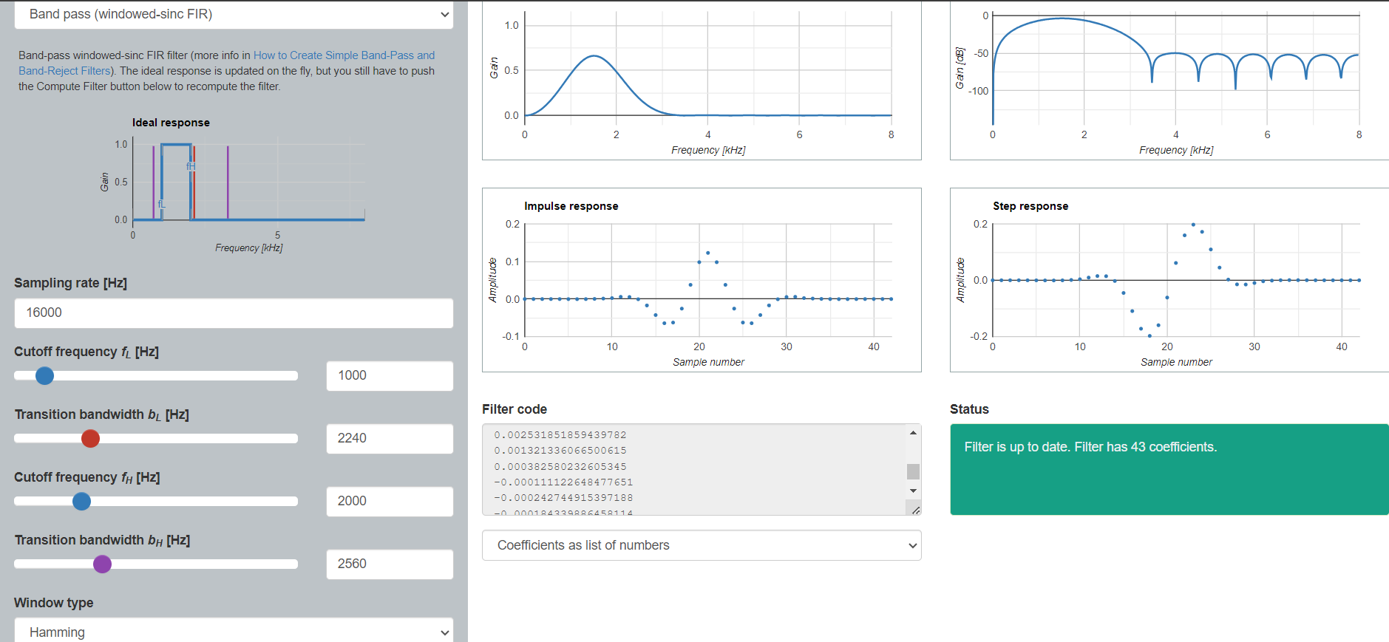

43 coefficients:

0.000005649828727282

0.000011552647988508

0.000011375411927826

-0.000013726321405765

-0.000082833470599655

-0.000184339886458081

-0.000242744915397165

-0.000111122648477646

0.000382580232605345

0.001321336066500628

0.002531851859439795

0.005955239670179236

0.005444871756643287

-0.000525497584419760

-0.016975576995901222

-0.042584637527489380

-0.064344497026355391

-0.062572199026970587

-0.025459205816811499

0.037857897314414787

0.098124775794584479

0.122898501274543534

0.098124775794583174

0.037857897314414871

-0.025459205816811284

-0.062572199026970754

-0.064344497026355335

-0.042584637527489401

-0.016975576995901291

-0.000525497584419778

0.005444871756643262

0.005955239670179253

0.002531851859439782

0.001321336066500615

0.000382580232605345

-0.000111122648477651

-0.000242744915397188

-0.000184339886458114

-0.000082833470599665

-0.000013726321405770

0.000011375411927821

0.000011552647988501

0.000005649828727287

### **1.3 Band 2-3khz**

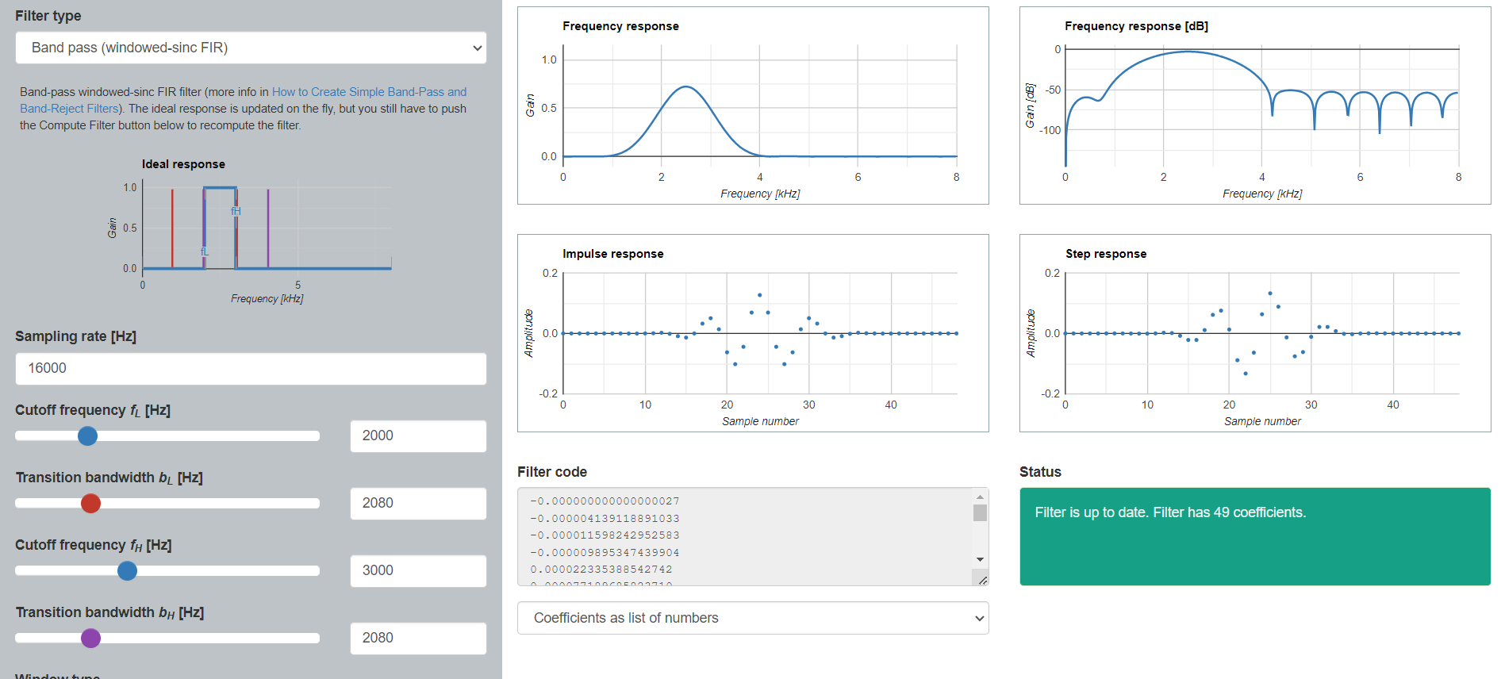

49 coefficients:

-0.000000000000000027

-0.000004139118891033

-0.000011598242952583

-0.000009895347439904

0.000022335388542742

0.000077189685823710

0.000077906830561317

-0.000068965625153438

-0.000308585959554247

-0.000348509550308228

0.000076453786719473

0.000637739860814855

0.002316876936158440

-0.001209835839289168

-0.009027070848881425

-0.013689888404203897

-0.000000000000000036

0.032590480345095069

0.050404881932726645

0.013892930351465795

-0.062408260575097380

-0.101495342804144684

-0.044100244299734283

0.069122759688375862

0.126925563618740023

0.069122759688377222

-0.044100244299735025

-0.101495342804145156

-0.062408260575097546

0.013892930351465878

0.050404881932726756

0.032590480345095041

0.000000000000000030

-0.013689888404203914

-0.009027070848881425

-0.001209835839289188

0.002316876936158434

0.000637739860814850

0.000076453786719474

-0.000348509550308199

-0.000308585959554207

-0.000068965625153433

0.000077906830561321

0.000077189685823725

0.000022335388542743

-0.000009895347439917

-0.000011598242952581

-0.000004139118891014

-0.000000000000000009

### **1.4 Band 3-4khz**

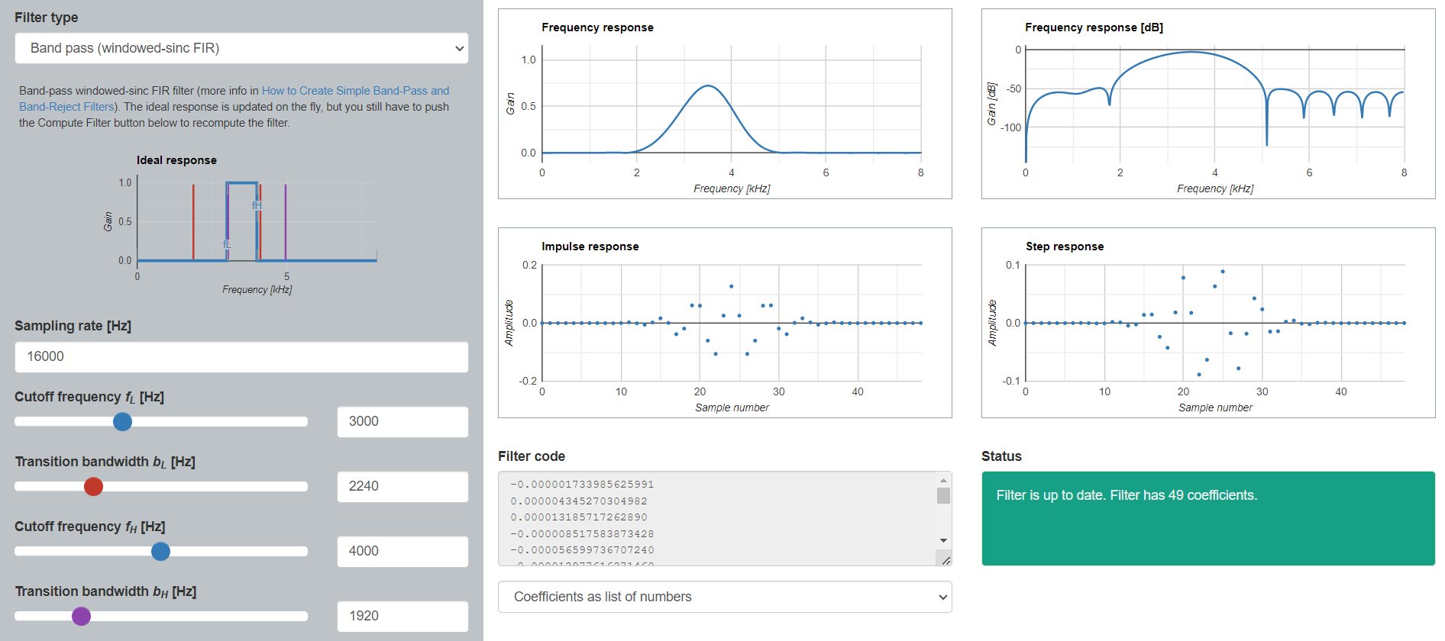

49 coefficients:

-0.000001733985625991

0.000004345270304982

0.000013185717262890

-0.000008517583873428

-0.000056599736707240

-0.000012977616271460

0.000153861289748774

0.000133293134473966

-0.000283815630112037

-0.000503431524011804

0.000078772967783499

0.002378240579970441

-0.000848362440701156

-0.005448492780476585

0.002013941932243070

0.016421842278359015

0.000606549388379371

-0.038260598162011682

-0.018878644984327585

0.060764585837606730

0.059640771345876240

-0.060408677680190613

-0.106028716864162043

0.025405496190471544

0.126251366111977403

0.025405496190469216

-0.106028716864162348

-0.060408677680190793

0.059640771345876767

0.060764585837606570

-0.018878644984327619

-0.038260598162011716

0.000606549388379510

0.016421842278359008

0.002013941932243036

-0.005448492780476603

-0.000848362440701127

0.002378240579970443

0.000078772967783500

-0.000503431524011847

-0.000283815630112050

0.000133293134473959

0.000153861289748786

-0.000012977616271468

-0.000056599736707235

-0.000008517583873425

0.000013185717262890

0.000004345270304972

-0.000001733985626000

### **1.5 Band 4-5khz**

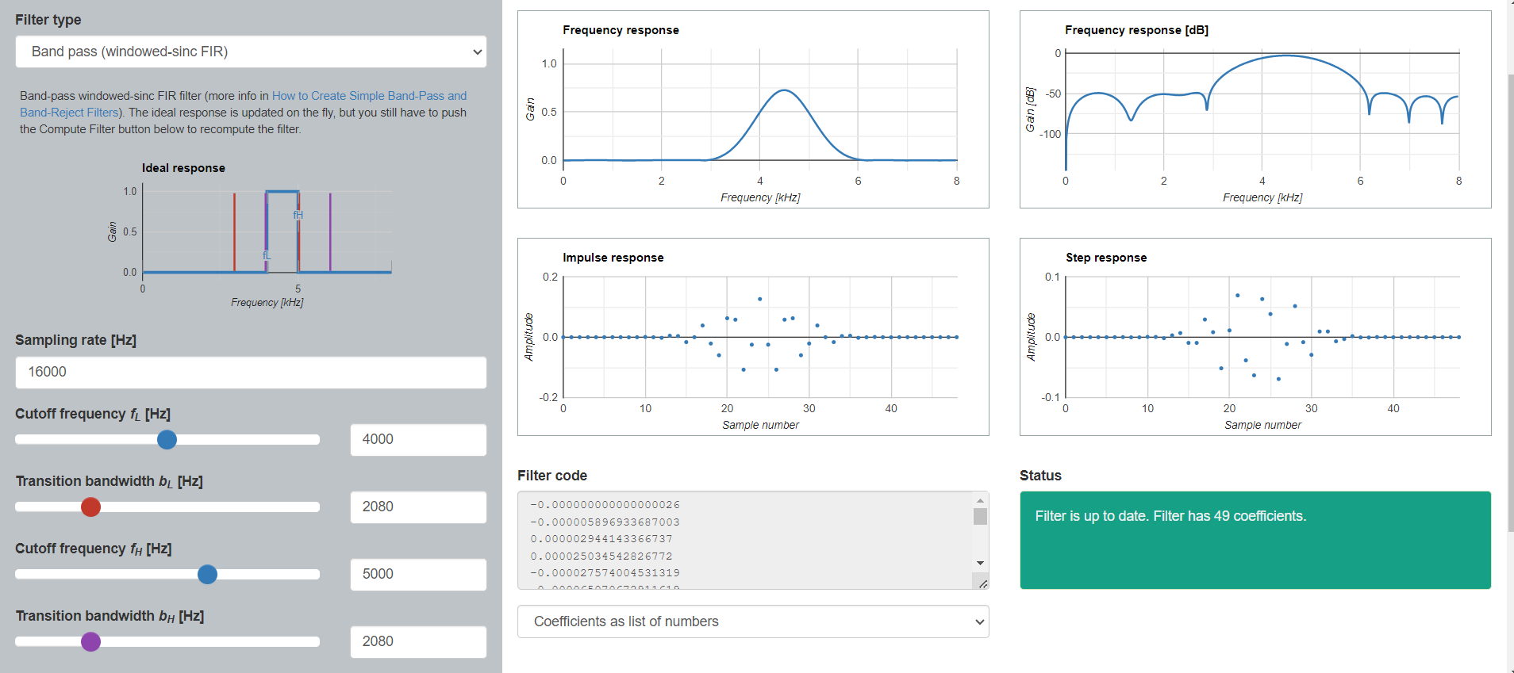

49 coefficients:

-0.000000000000000026

-0.000005896933687003

0.000002944143366737

0.000025034542826772

-0.000027574004531319

-0.000065070672911619

0.000122983541820547

0.000094321032307422

-0.000358847559568117

-0.000005104161333382

0.000757646981074859

-0.000188626171955629

-0.002022159922426013

0.004766910945011232

0.003696399278718689

-0.016241303975020743

-0.000000000000000044

0.038675952390661954

-0.020978483623732832

-0.059709796654197463

0.062672145523127026

0.057952045855620263

-0.107481175483230718

-0.024783731705391554

0.126202773266910068

-0.024783731705392050

-0.107481175483232536

0.057952045855620540

0.062672145523127207

-0.059709796654197789

-0.020978483623732891

0.038675952390661870

0.000000000000000025

-0.016241303975020813

0.003696399278718684

0.004766910945011220

-0.002022159922425996

-0.000188626171955634

0.000757646981074853

-0.000005104161333389

-0.000358847559568080

0.000094321032307419

0.000122983541820565

-0.000065070672911629

-0.000027574004531319

0.000025034542826781

0.000002944143366745

-0.000005896933687007

-0.000000000000000005

### **1.6 Band 5-6khz**

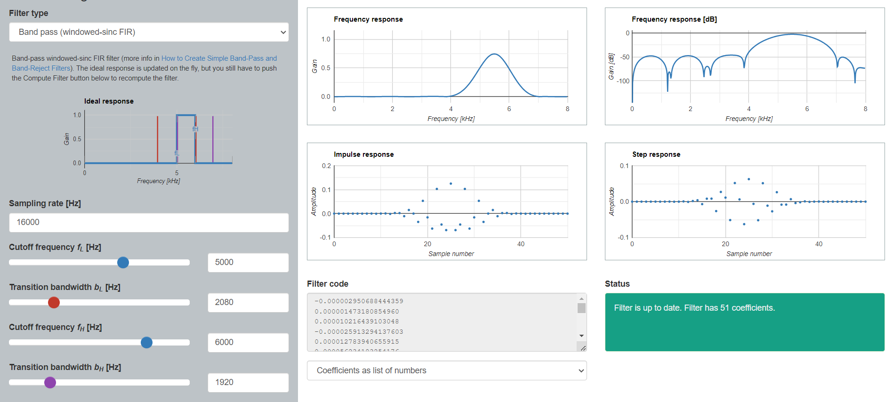

51 coefficients:

-0.000002950688444359

0.000001473180854960

0.000010216439103048

-0.000025913294137603

0.000012783940655915

0.000056234183254176

-0.000127536131224376

0.000062431997351431

0.000199829347623515

-0.000432661009327346

0.000192617470276582

0.000655663562123813

-0.001335727188229814

0.002463510301382952

0.002145368576222265

-0.010769399462276981

0.015101736067773031

0.000184975579450169

-0.034696747173959409

0.053321797066083358

-0.015784430024754083

-0.062612706915839117

0.103169274814735312

-0.045559806098128278

-0.068937787608078949

0.125415506135026167

-0.068937787608080975

-0.045559806098128305

0.103169274814735562

-0.062612706915839589

-0.015784430024753816

0.053321797066083393

-0.034696747173959507

0.000184975579450393

0.015101736067773010

-0.010769399462277014

0.002145368576222320

0.002463510301382929

-0.001335727188229814

0.000655663562123825

0.000192617470276553

-0.000432661009327315

0.000199829347623526

0.000062431997351431

-0.000127536131224398

0.000056234183254183

0.000012783940655915

-0.000025913294137603

0.000010216439103042

0.000001473180854973

-0.000002950688444361

### **1.7 Band 6-7khz**

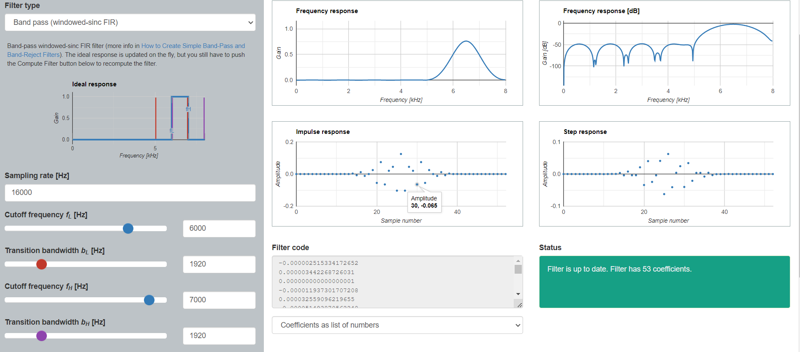  
53 coefficients:

-0.000002515334172652

0.000003442268726031

0.000000000000000001

-0.000011937301707208

0.000032559096219655

-0.000051493870562248

0.000046042319982933

0.000010659777744220

-0.000130560223639209

0.000284902570651375

-0.000381546143082689

0.000261035251926991

0.000269248170401476

0.000045439754242777

0.002917381442675567

-0.007313767910252589

0.011773314881528892

-0.011466024749393821

0.000000000000000006

0.024765816135420726

-0.055189734749960903

0.074344279165287061

-0.064690054130826208

0.020468424493750050

0.044953333474882409

-0.103413821650349735

0.124951154521008412

-0.103413821650348431

0.044953333474882617

0.020468424493749769

-0.064690054130826263

0.074344279165286936

-0.055189734749960861

0.024765816135420775

0.000000000000000067

-0.011466024749393842

0.011773314881528898

-0.007313767910252593

0.002917381442675553

0.000045439754242781

0.000269248170401475

0.000261035251926982

-0.000381546143082659

0.000284902570651346

-0.000130560223639210

0.000010659777744229

0.000046042319982936

-0.000051493870562253

0.000032559096219653

-0.000011937301707211

0.000000000000000008

0.000003442268726020

-0.000002515334172653

### **1.8 Band 7-8khz**

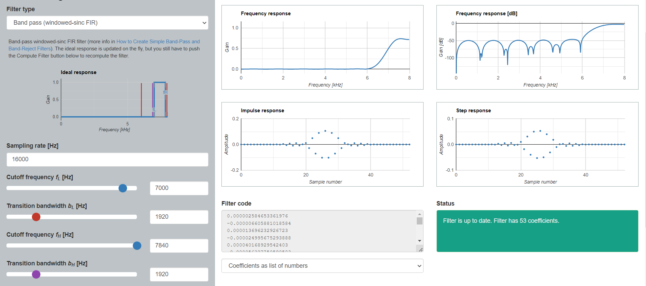

53 coefficients:

0.000002584653361976

-0.000006605881018584

0.000013696232926723

-0.000024995675293888

0.000040168929542403

-0.000056327750590583

0.000066935724745196

-0.000060799759972981

0.000021299207997681

0.000073942433809304

-0.000252701818233611

0.000546884739345309

-0.000990187757964943

0.003422472282262685

-0.004921002648865973

0.007045797582673137

-0.009179846180265662

0.010029370854418858

-0.007906038988303977

0.001230884565899027

0.010884638277843282

-0.028167774393371661

0.048993443450360934

-0.070567123428951412

0.089464160444533952

-0.102395668885781693

0.105385587577783588

-0.102395668885781013

0.089464160444534174

-0.070567123428951911

0.048993443450360982

-0.028167774393371453

0.010884638277843283

0.001230884565898967

-0.007906038988303939

0.010029370854418823

-0.009179846180265658

0.007045797582673156

-0.004921002648865967

0.003422472282262675

-0.000990187757964942

0.000546884739345312

-0.000252701818233602

0.000073942433809297

0.000021299207997674

-0.000060799759972976

0.000066935724745201

-0.000056327750590588

0.000040168929542406

-0.000024995675293887

0.000013696232926729

-0.000006605881018589

0.000002584653361974

## **2. Xác định số fixing point**

-Sử dụng 16bit: 1 bit dấu và 15 bit phân số.

-Khoảng giá trị: [-1, 0.999969482421875]

# II. Cấu trúc của bộ lọc

## **1. Top_layer**

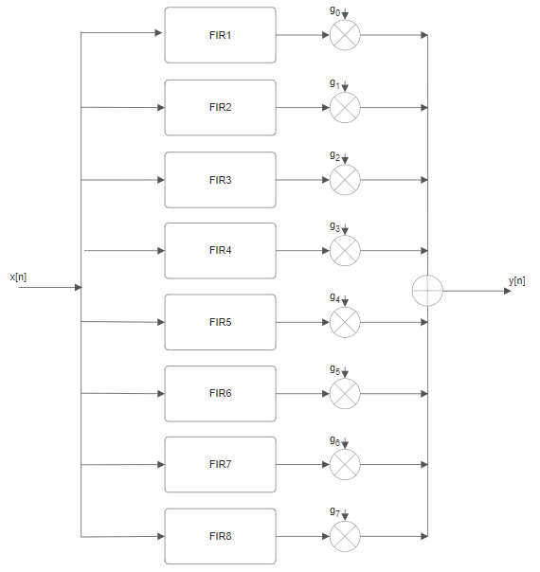

Table . Port description

|  |  |  |  |
| --- | --- | --- | --- |
| **Name** | **Width** | **In/Out** | **Description** |
| clk | 1 | Input | Xung đồng hồ |
| rst | 1 | Input | Reset |
| ena | 1 | Input | Tín hiệu kích hoạt |
| x[n] | 16 | Input | Tín hiệu 16bit đầu vào |
| g0, g1, g2, g3, g4, g5, g6, g7 | 8 bit each | Input | Gain |
| y[n] | 16 | Output | Tín hiệu 16bit đầu ra |

## **2. Sub module**

Cấu trúc vật lý:

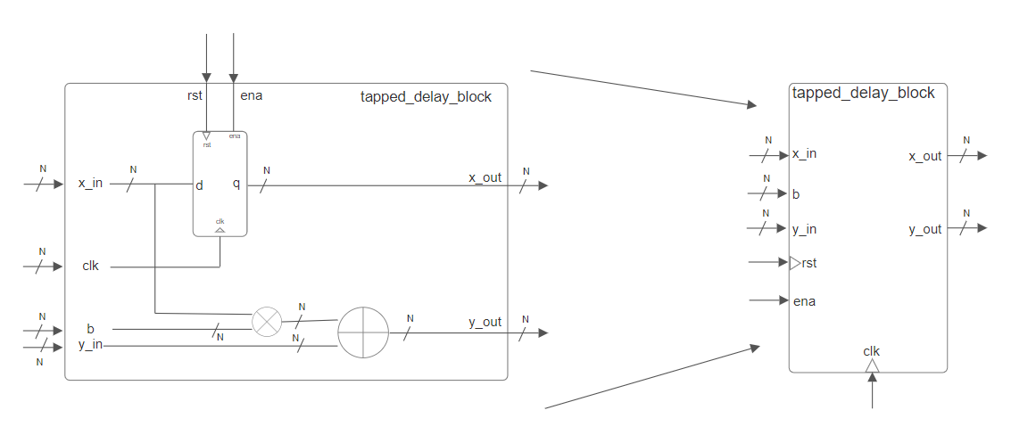

N là số bit đầu vào

### 2.1 FIR1

#### a. Cấu trúc logic

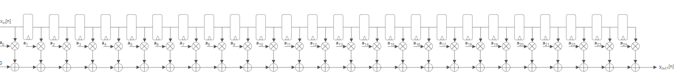

a0, a1, a2,.... a24 là các hệ số của FIR1 (band 0-1kHz)

#### b. Cấu trúc vật lý

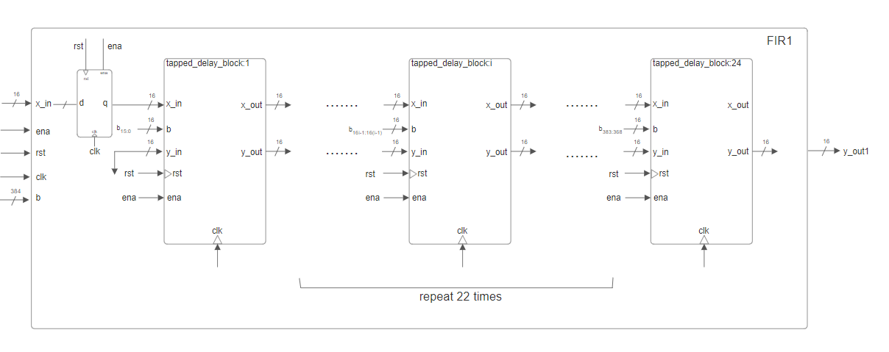

### 2.2 FIR2

#### a. Cấu trúc logic



b0, b1, b2, ..b42 là các hệ số của FIR2 (band 1-2kHz)

#### b. Cấu trúc vật lý

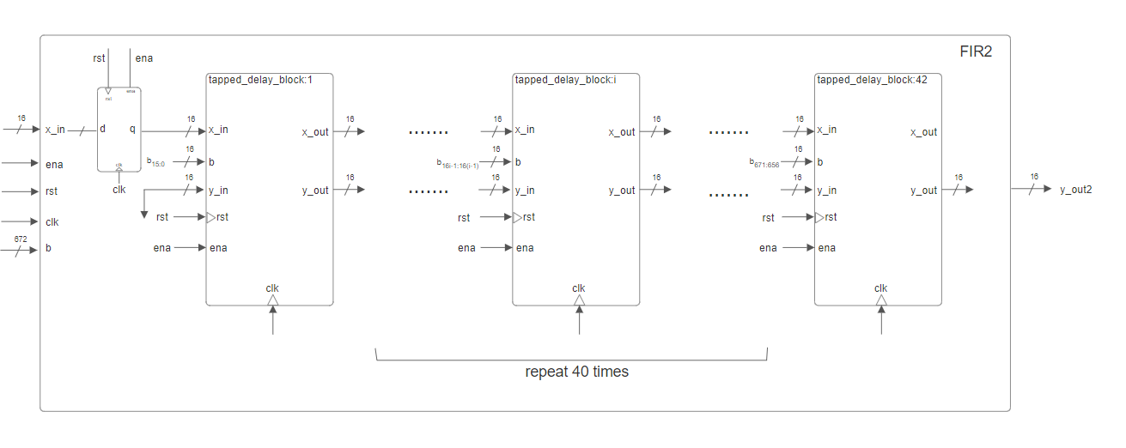

### 2.3 FIR3

#### a. Cấu trúc logic



c0, c1, c2,.., c48 là các hệ số của FIR3 (band 2-3kHz)

#### b. Cấu trúc vật lý

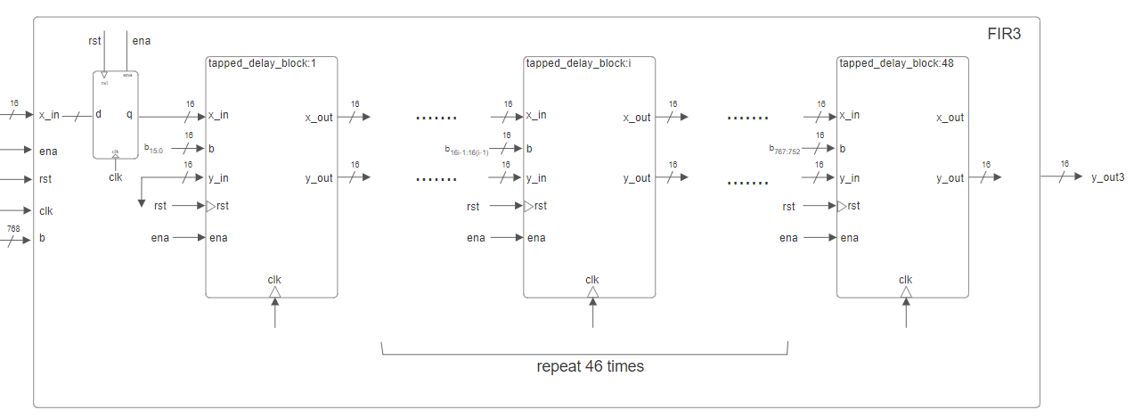

### 2.4 FIR4

#### a. Cấu trúc logic



d0, d1, d2,...d48 là các hệ số của FIR4 (band 3-4kHz)

#### b. Cấu trúc vật lý

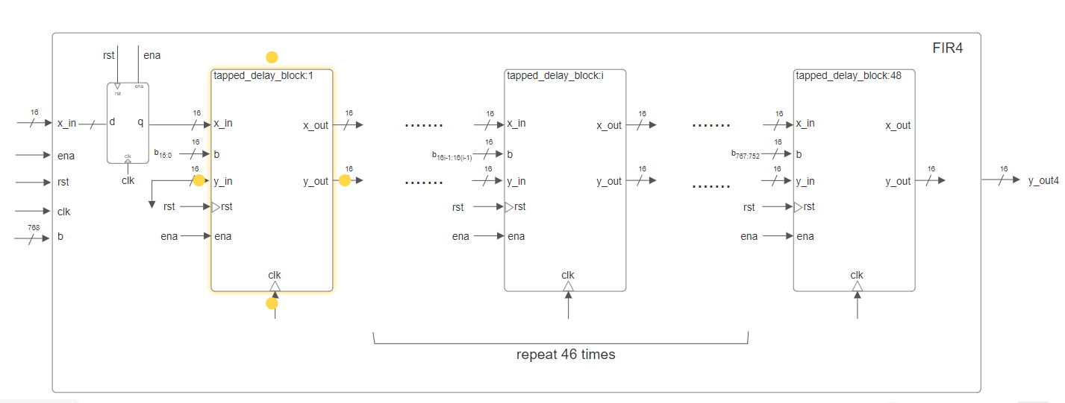

### 2.5 FIR5

#### a. Cấu trúc logic



e0, e1, e2,...,e48 là các hệ số của FIR5 (band 4-5kHz)

#### b. Cấu trúc vật lý

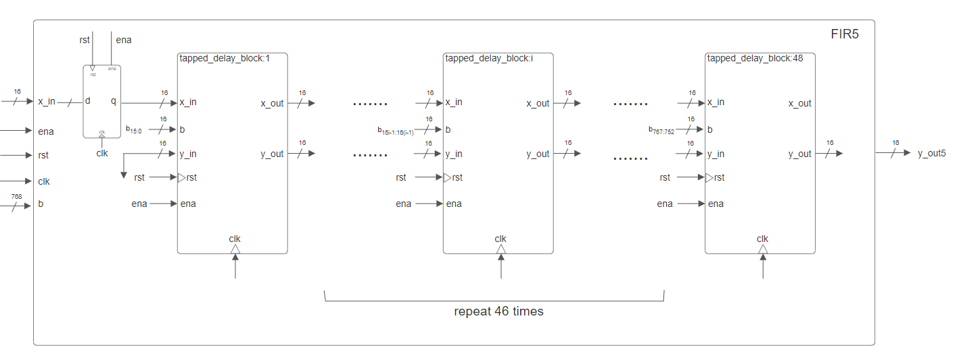

### 2.6 FIR6

#### a. Cấu trúc logic



f0, f1, f2,...f50 là các hệ số của FIR6 (band 5-6kHz)

#### b. Cấu trúc vật lý

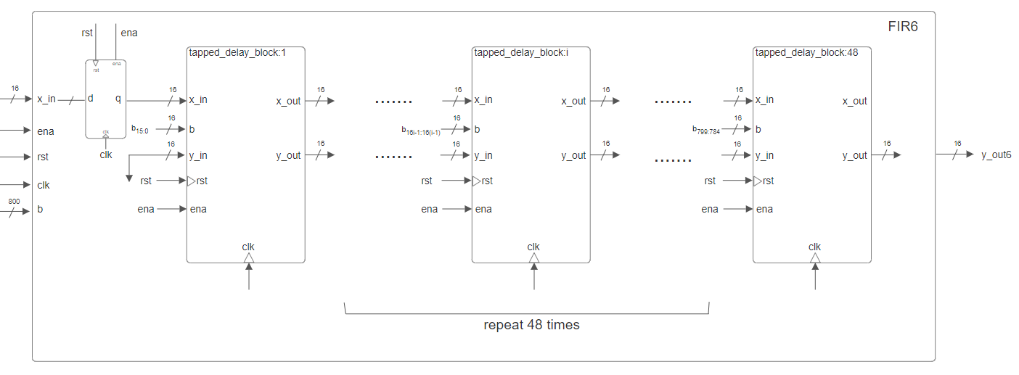

### 2.7 FIR7

#### a. Cấu trúc logic



h0, h1, h2,...h52 là các hệ số của FIR7 (band 6-7kHz)

#### b. Cấu trúc vật lý

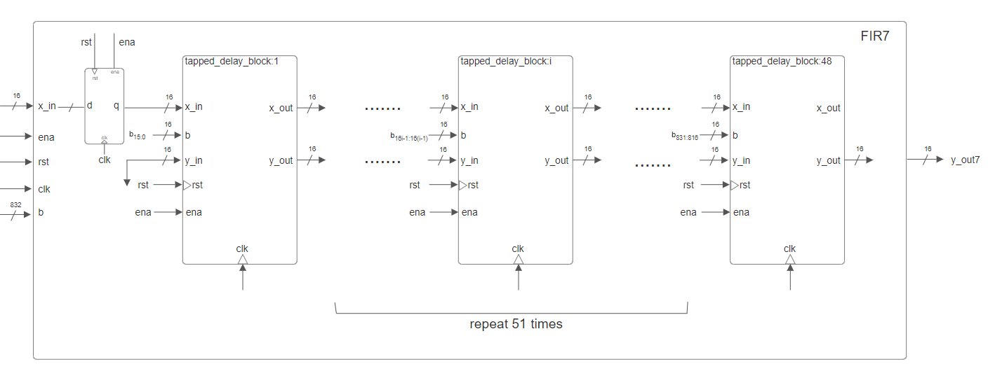

### 2.8 FIR8

#### a. Cấu trúc logic



i0, i1, i2,...i52 là các hệ số của FIR8 (band 7-8kHz)

#### b. Cấu trúc vật lý

